Memory-Mapped Interface (MMI) of RISC-V with UART 2
1. Title 2
2. Objective 2
3. Theory (Multi-Level) 2
3.1 Beginner — Simple Intuition 2
3.2 Intermediate — Engineering View 3
3.3 Advanced — Signal/Architecture Level 3
4. Architecture / Concept 4
Block Diagram: MMI Design (No AXI) 4
CPU ↔ UART Communication Flow (Firmware Perspective) 4
Status Register Polling (uart_getc) 5
5. Implementation 6
Files in This Module 6
Firmware Key Functions (fw/main.c) 6
6. Lab / Hands-on Section 6
Step 1: Build Firmware Separately (Optional) 6
Step 2: Run the Full MMI SoC Simulation 7
Expected Terminal Output 7
Step 3: View Waveforms 7
7. Waveform / Verification Insight 8
Key Signals to Monitor 8
Observations 8
8. Common Issues & Debug Tips 8
Debugging MMIO: Address Watch 9
9. Summary 9

Memory-Mapped Interface (MMI) of RISC-V with UART
Course: PicoRV32 SoC with AXI-Lite & UART Integration
Lab Commands: make soc_pico_uart_mem → make fw → make wave

1. Title
Memory-Mapped Interface (MMI) — Connecting PicoRV32 to UART Without AXI

2. Objective
By the end of this module, learners will be able to:
- Explain Memory-Mapped I/O (MMIO) and why it is foundational to embedded systems
- Map UART TX, RX, and STATUS registers to specific memory addresses in software
- Understand how the PicoRV32 mem_valid/mem_ready bus translates to peripheral register access
- Run the picorv32_uart_mem sub-project and observe CPU ↔ UART communication
- Write simple C firmware that reads/writes UART through fixed memory addresses

3. Theory (Multi-Level)

3.1 Beginner — Simple Intuition
In a typical embedded system, instead of having separate wires for each peripheral command, we use the memory address space as a control panel. Each peripheral is assigned a range of addresses:
- Write to address 0x10000000 → Send a byte over UART
- Read from address 0x10000004 → Get the received UART byte
- Read from address 0x10000008 → Check if data is available
This is called Memory-Mapped I/O (MMIO). The CPU doesn’t need special hardware for each peripheral — it just uses the same load/store instructions it uses for RAM.
Analogy: Imagine a hotel room with a panel of buttons. Pressing button #1 calls room service, button #2 calls housekeeping, button #3 dims the lights. The CPU presses a “button” (issues a store to an address) and the hardware responds.

3.2 Intermediate — Engineering View
In the picorv32_uart_mem design: - PicoRV32 generates mem_addr + mem_valid + mem_wstrb for every access - An address decoder routes the request to either ROM, SRAM, or UART based on the address - The UART peripheral accepts mem_wdata directly without AXI protocol overhead

UART Register Map (from fw/main.c):
#define UART_TX (*(volatile char*)0x10000000) // Write → transmit byte
#define UART_RX (*(volatile char*)0x10000004) // Read → received byte
#define UART_STATUS (*(volatile int*)0x10000008) // Read → [1]=RX ready
volatile keyword: Tells the C compiler not to optimize away hardware register accesses. Without it, the compiler might cache the value in a CPU register and never actually perform the memory-mapped access.

3.3 Advanced — Signal/Architecture Level
Address Range Decoding (direct mem-mapped, no AXI):
CPU addr [31:0] → Combinational decode:
[31:16] == 16'h0000 AND [15] == 0 → ROM (0x0000_0000 – 0x0000_7FFF)
[31:16] == 16'h0001 → SRAM (0x0001_0000 – 0x0001_FFFF)
[31:28] == 4'h1 → UART (0x1000_0000 – 0x1000_000F)
UART access via direct mem bus:
// mem_uart: Write side
if (mem_valid && (|mem_wstrb) && uart_sel) begin
uart_tx_data <= mem_wdata[7:0]; // grab byte from CPU write
uart_tx_valid <= 1'b1; // trigger UART TX
end
// mem_uart: Read side
if (mem_valid && (!|mem_wstrb) && uart_sel) begin
if (mem_addr[3:0] == 4'h8)
mem_rdata <= {30'b0, rx_valid, 1'b0}; // status register
else
mem_rdata <= {23'b0, rx_valid, rx_data}; // RX data register
end
System memory map (full picture):
Address Range | Peripheral | Interface
0x0000_0000 – 0x0000_7FFF | ROM (program) | Direct native bus
0x0001_0000 – 0x0001_FFFF | SRAM (data) | Direct native bus
0x1000_0000 – 0x1000_000F | UART | Direct native bus

4. Architecture / Concept

Block Diagram: MMI Design (No AXI)
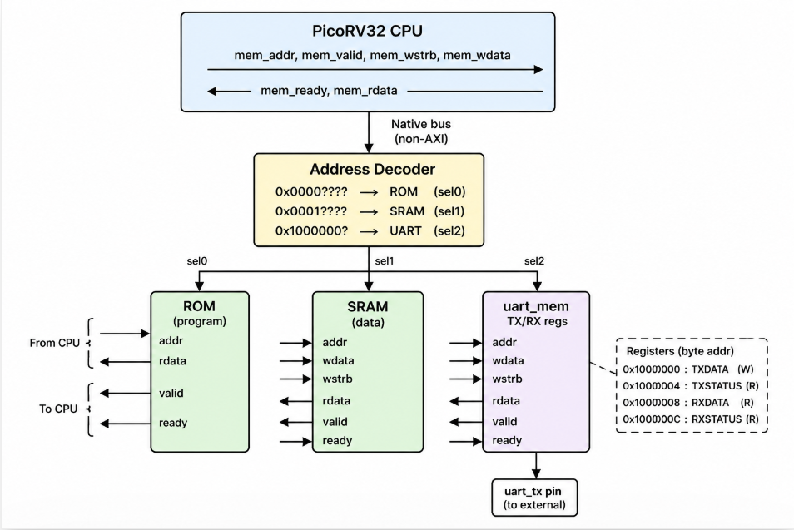

CPU ↔ UART Communication Flow (Firmware Perspective)
firmware main.c:
1. uart_puts("Hello Deepak from Nielit!\n")
│
├─ uart_putc('H')
│ └─ UART_TX = 'H'
│ └─ SW x05, 0(x11) [store byte to 0x10000000]
│ └─ PicoRV32: mem_valid=1, mem_wstrb=0x1, mem_addr=0x10000000
│ mem_wdata=0x48
│ → UART starts transmitting 'H'
│
├─ uart_putc('e') (next iteration)
...

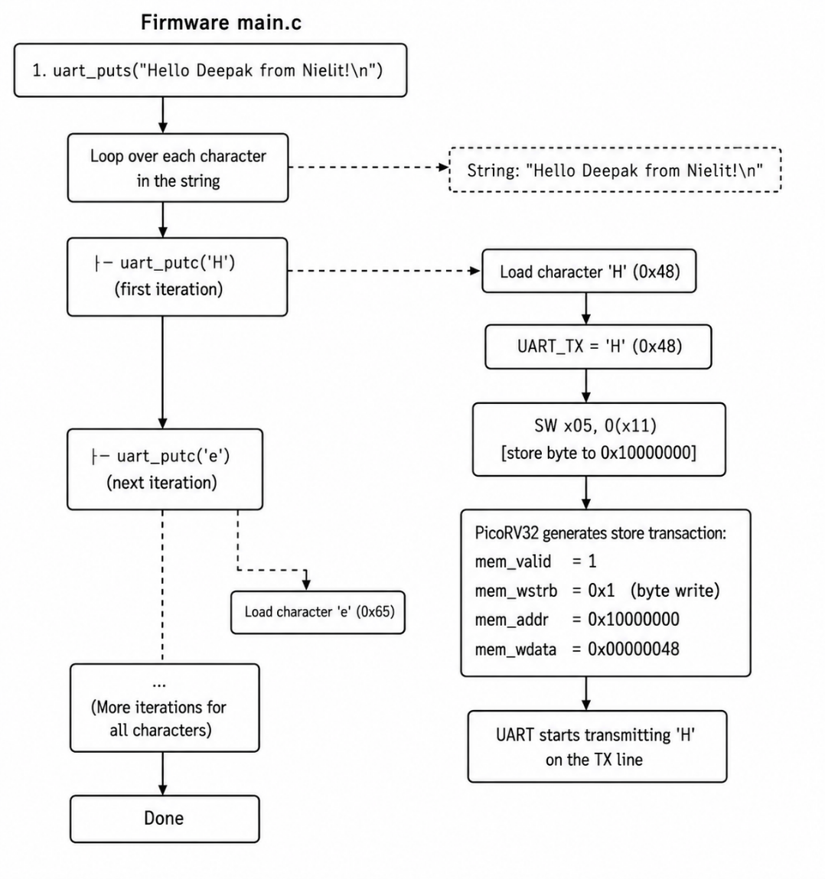

Status Register Polling (uart_getc)
while (!(UART_STATUS & 0x2)); // Poll bit 1 = RX ready
return UART_RX; // Read received byte
LW a0, 8(uart_base) ; load status register
ANDI a0, a0, 2 ; check bit 1 (RX ready)
BEQ a0, x0, loop ; retry if not ready
LW a1, 4(uart_base) ; load received byte

5. Implementation

Files in This Module
File | Role
picorv32_uart_mem/rtl/top.v | MMI SoC top — CPU + ROM + SRAM + UART (direct bus)
picorv32_uart_mem/rtl/uart_mem.v | Direct-bus UART peripheral (no AXI)
picorv32_uart_mem/rtl/mem_rom.v | ROM with native memory interface
picorv32_uart_mem/rtl/mem_sram.v | SRAM with native memory interface
fw/main.c | Firmware: prints greeting 10× then echo loop
fw/crt0.S | C runtime startup: stack init + call main
fw/link.ld | Linker script: ROM from 0x0, STACK at 0x1_00FC
picorv32_uart_mem/tb/tb_mem_soc.v | Testbench: UART monitor + PING test

Firmware Key Functions (fw/main.c)
#define UART_TX (*(volatile char*)0x10000000)
#define UART_RX (*(volatile char*)0x10000004)
#define UART_STATUS (*(volatile int*)0x10000008)
static void uart_putc(char c) { UART_TX = c; }
static void uart_puts(const char *s) {
while (*s) uart_putc(*s++);
}
static char uart_getc(void) {
while (!(UART_STATUS & 0x2)); // Wait for RX ready
return UART_RX;
}
int main(void) {
for (int i = 0; i < 10; i++)
uart_puts("Hello Deepak from Nielit!\n");
while (1) uart_putc(uart_getc()); // Echo loop
}

6. Lab / Hands-on Section

Step 1: Build Firmware Separately (Optional)
cd /home/deep/nielit/projects/tested_projects/picorv32_soc/fw
make
# Produces: firmware.elf, firmware.bin, rom.hex
The firmware build chain:
main.c + crt0.S → (riscv32-unknown-elf-gcc) → firmware.elf
firmware.elf → (objcopy) → firmware.bin
firmware.bin → (bin2hex.py) → rom.hex (for $readmemh in RTL)

Step 2: Run the Full MMI SoC Simulation
cd /home/deep/nielit/projects/tested_projects/picorv32_soc
make soc_pico_uart_mem
This command: 1. Builds firmware in picorv32_uart_mem/fw/ 2. Compiles the MMI SoC RTL + testbench with Verilator 3. Runs the simulation → produces tb_mem_soc.vcd/.fst 4. Opens GTKWave automatically

Expected Terminal Output
--------------------------------------------------
UART SoC Simulation Started
--------------------------------------------------
[TB] UART Monitor Started
--------------------------------------------
[TB] RX byte: H
[TB] RX byte: e
[TB] RX byte: l
[TB] RX byte: l
[TB] RX byte: o
...
[TB] Greeting message count = 10
============================================
10 GREETING MESSAGES RECEIVED
UART OUTPUT VERIFIED
============================================
--------------------------------------------
[TB] FIFO flushed – sending command : PING
--------------------------------------------
[TB] RX byte: P
[TB] RX byte: I
[TB] RX byte: N
[TB] RX byte: G
============================================
TEST PASSED
Echo received : PING
============================================

Step 3: View Waveforms
make wave # Opens tb_top.fst (or tb_mem_soc.fst for this target)

7. Waveform / Verification Insight

Key Signals to Monitor
clk
reset
cpu_mem_valid
cpu_mem_instr
cpu_mem_ready
cpu_mem_addr[31:0]
cpu_mem_wstrb[3:0]
cpu_mem_wdata[31:0]
uart_sel ← goes high when addr = 0x10000000
uart_tx ← serial bitstream output
uart_mem.tx_valid ← TX trigger from CPU
uart_mem.rx_data_valid ← RX byte received

Observations
- Instruction fetches: cpu_mem_instr=1, addr incrementing through ROM space (0x0000_0004, 0x0000_0008, …)
- UART TX write: cpu_mem_valid=1, cpu_mem_wstrb=4'b0001, cpu_mem_addr=0x1000_0000, cpu_mem_wdata[7:0] = 0x48 ('H')
- UART byte serialized: After the write, uart_tx transitions from 1→0 (start bit) then through 8 data bits over 4340 clock cycles
- Status poll: CPU repeatedly reads 0x1000_0008 until bit 1 is set (PING phase)
- Echo path: CPU reads 0x1000_0004, then writes it back to 0x1000_0000

8. Common Issues & Debug Tips
Issue | Likely Cause | Fix
soc_pico_uart_mem fails to build | Firmware not compiled | Run cd fw && make first
0 greeting messages received | ROM not loaded | Check +romhex= plusarg path in Makefile
UART TX flat (never transitions) | CPU never reaches uart_putc call | Check stack and PC trace — bad linker script?
Status poll hangs forever | uart_status bit mapping wrong | Verify UART_STATUS bit 1 = RX ready in RTL
Echo sends wrong character | UART_RX reads stale data | Ensure rx_buf_valid clears after read
Simulation times out | CPU in infinite wait loop | Add $display monitoring of cpu_mem_addr to track CPU state

Debugging MMIO: Address Watch
In the testbench, add this always block for immediate feedback:
always @(posedge clk) begin
if (mem_valid && mem_addr == 32'h10000000 && |mem_wstrb)
$display("[DBG] UART TX write: 0x%02h ('%c')", mem_wdata[7:0], mem_wdata[7:0]);
end

9. Summary
Concept | Detail
MMI | Peripherals mapped to CPU address space; accessed via load/store
UART registers | TX: 0x1000_0000
volatile in C | Prevents compiler from caching hardware register reads
Address decode | Combinational logic maps address ranges to peripheral select signals
Blocking RX | uart_getc() polls STATUS bit 1 until RX data is available
Lab result | CPU prints 10× “Hello Deepak from Nielit!” then echoes “PING” → TEST PASSED
vs Sub-module 5+ | This Sub-module uses a direct native bus; Sub-module 5+ adds full AXI-Lite protocol
This Sub-module bridges the gap between raw RISC-V ISA knowledge (Sub-module 1) and the full AXI-based SoC (Sub-modules 5–8). Understanding MMIO is essential for all embedded firmware development.

Previous: Sub-module 3 — UART
Next: Sub-module 5 — RISC-V AXI Integration

